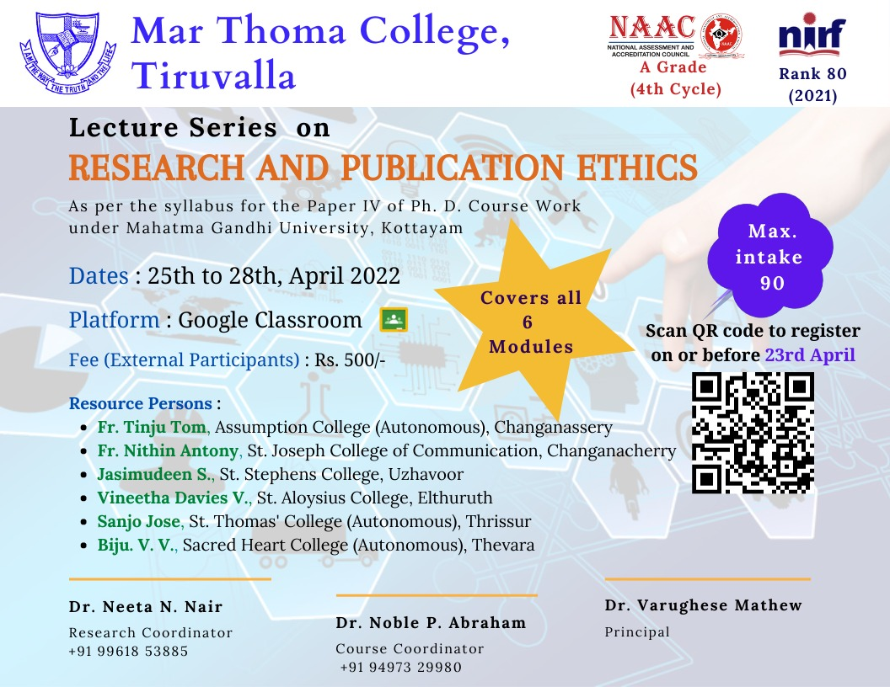

**Report of the Short-Term Programme on**

**“Research and Publication Ethics**” 2022

A Lecture series on‘Research and Publication Ethics’ was conducted from 25-04-2022 to 28-04-2022 in the online platform through G-meet. The programme was inaugurated by Dr. Varughese Mathew, Principal Mar Thoma College, Tiruvalla.

A total of 74 participants registered for this course of which 54 were external participants including teachers and research scholars from various parts of Kerala and outside Kerala. All the modules of Paper IV were covered in this session and internal examination also conducted.Details regarding this lecture series is attached here with.

With Regards

Sd/-

Dr. Neeta N. Nair, Research Coordinator

Dr. Noble P. Abraham, Course Coordinator

**REGISTERED STUDENTS 2021-2022**

|  |  |  |  |
| --- | --- | --- | --- |
| SL. NO. | Name | Name of the Institute / College | Faculty |
| 1 | Abraham Mathew | St.Thomas College, Kozhencherry | Humanities |
| 2 | Adithyan S | MAR THOMA COLLEGE TIRUVALLA | Science |
| 3 | Aleesha Sara Mani | MAR THOMA COLLEGE, THIRUVALLA | Languages |
| 4 | Alert Mathew Joseph | Mar Thoma College, Tiruvalla | Social Sciences |
| 5 | Aloshious Xavier | MAR THOMA COLLEGE, THIRUVALLA | Humanities |
| 6 | Ammu Kishore | Mar Thoma College, Tiruvalla | Humanities |
| 7 | Anisha Joseph | Federal Institute of Science and Technology, FISAT, Angamaly | Science |
| 8 | Ann Johns | Bishop Chulaparambil Memorial College, Kottayam | Science |
| 9 | Ann Mary Jose | Bishop Moore College, Mavelikara | Science |
| 10 | Anna Joshy | BK College, Amalagiri | Humanities |
| 11 | Anu Ann James | Mar Thoma College , Tiruvalla | Science |
| 12 | Arathy K D | M P M M S N Trusts College, Shoranur | Science |
| 13 | Aravind Sankar N | Mar Thoma College, Tiruvalla | Humanities |
| 14 | Arya A Varma | Waiting for joining order for Ph.D registration in Sanskrit at Maharaja's College, Ernakulam | Languages |
| 15 | Asha M | Govt Arts and Science College Kozhikode | Commerce |
| 16 | Assanu Augustine | Marian College Kuttikkanam (Autonomous ) | Science |
| 17 | Aswathy G Babu | Mar Thoma College, Tiruvalla | Languages |
| 18 | Aswathy S Nair | NSS Hindu College, Changanacherry | Science |
| 19 | Athira Krishnan | Sree Narayana College, Nattika | Science |
| 20 | Athulya Mariam Sam | St. Thomas College, Kozhencherry | Languages |
| 21 | Basil Roy Idiculla | Mar Thoma College, Tiruvalla | Mathematics |
| 22 | Bhanupriya S | Sree Narayana College Cherthala | Science |
| 23 | Bitty Joseph | St. George's College Aruvithura | Science |
| 24 | Deepa Sarah Mathew | Mar Thoma College, Thiruvalla | Languages |
| 25 | Deepa Susan Oommen | Catholicate College, Pathanamthitta | Science |
| 26 | Deepthi J Panicker | Nss college changanacherry | Languages |
| 27 | Dhanya Raj | Dhanya Raj | Science |
| 28 | Divya J | DB College Thalayolaparambu | Science |
| 29 | Diya Jose | Mar Thoma College Tiruvalla | Languages |
| 30 | Dr. Priti Shrivastava | Dr. R.B.GOVT .NAVEEN KANYA MAHAVIDYALAYA RAIPUR | Science |
| 31 | Elizabeth George | St. Cyril's College, Adoor | Humanities |
| 32 | Emilda George | St. Thomas College Kozhencherry | Humanities |
| 33 | Jaseel. P. H | MES Asmabi College, P. Vemballur | Commerce |
| 34 | Jassi J | Mar Athanasius College(Autonomous), Kothamangalam | Science |
| 35 | Jincy Stephen | GOVT. POLYTECHNIC COLLEGE MUTTOM | Science |
| 36 | Jisha Elezaba | Catholicate College, Pathanamthitta | Languages |
| 37 | Jovita James | Maharaja's College, Ernakulam | Languages |
| 38 | Karthika P Nair | SVR NSS College Vazhoor | Commerce |
| 39 | Karthika.S | St Thomas college | Science |
| 40 | Lakshmi C.S | St Albert's College Ernakulam | Science |
| 41 | Lakshmi S | Henry Baker college | Humanities |
| 42 | Lenittamol Abraham | CMS College Kottayam | Research Scholar- Department of Commerce |
| 43 | Liny Mariam Mathew | DB College Thalayolaparambu | Science |
| 44 | Manju P K | Govt Polytechnic College, Kaduthuruthy | Science |
| 45 | Mariya James | CMS College, Kottayam | Commerce |
| 46 | Mathu Devaraj | Mar Thoma College Thiruvalla | Science |
| 47 | Namita Mary Mathew | Maharaja’s College Ernakulam | Science |
| 48 | Niranjana Marian George | Maharaja's College, Ernakulam | Languages |
| 49 | Noble C Kurian | NEWMAN COLLEGE THODUPUZHA | Science |
| 50 | Prasad K A | MAHARAJAS COLLEGE,ERNAKULAM | Science |
| 51 | Preethi Elsi Thomas | St.Thomas College, Kozhencherry | Science |
| 52 | Rajalakshmi. A | Government College Kottayam | Humanities |
| 53 | Rani Thomas | St. Dominic's College kanjirapally | Humanities |
| 54 | Rekha Jose | St Dominic's College, Kanjirapally | Social Sciences |
| 55 | Reshmi P | Catholicate College,Pathanamthitta | Science |
| 56 | Richu Rajan | Mar Athanasius College,Kothamangalam | Science |
| 57 | Rose Mary Baby | Viswajyothi College of Engineering and Technology | Science |
| 58 | Roshin T Roy | Mar Thoma College, Thiruvalla | Languages |
| 59 | Sandra Jose | S D College Alappuzha | Science |
| 60 | Sanesh K P | Department of Commerce, Pondicherry University | Commerce |
| 61 | Sherin George | B K College Amalagiri, Kottayam | Social Science |
| 62 | Sincy Davis | Mar Thoma college, Thiruvalla | Humanities |
| 63 | Soumya Maria | St. Dominic's College Kanjirapally | Humanities |
| 64 | Sowmya Mary Thomas | St Cyril's College Adoor | Languages |
| 65 | Sreena S R | Marthoma college Thiruvalla | Science |
| 66 | Sruthi.C.C | PRNSS College,Mattannur |  |
| 67 | Suchithra P P | Govt Arts and Science College, Chelakkara, Thrissur | Commerce |
| 68 | Sudheesh P Thankappan | Newman College, Thodupuzha | Science |
| 69 | Swetha C | St. Thomas College, Ranni | Science |
| 70 | Thansila M.M | MES Asmabi college, kodungalloor | Commerce |
| 71 | Tisha Liza Tomy | St.Mary's College Thrissur | Science |
| 72 | Venkidesh T V | The Cochin college Kochin-2 | Science |
| 73 | Vidya T P | Federal Institute of Science and Technology | Science |
| 74 | Vinu Varghese Kurian | Mar Thoma College, Tiruvalla | Languages |

