**EXTENSION PROGRAMMES**

**2021-‘22**

**Extension Programmes**

* **HOME PROJECT** :

The Home project of the College was inaugurated in 2021. The project aimed to collect money from former and present students, teachers, well-wishers, philanthropists to construct a home for any of our fraternity members who were in need of a home. Under this project, 2 homes were built and one home was renovated.

The beneficiaries were Mr Murali (watchman), Ms Karthika Nair (MA Economics student) and Ms Monisha (former student and temporary staff of the college).

The Principal gave an appeal to all the members of the staff and students and the local community to support the noble cause. The NCC unit collected and donated an amount to the cause. The NSS unit conducted a food festival and donated the proceedings of the event to the project. Many staff members, students and well- wishers gave generous contributions to the project.

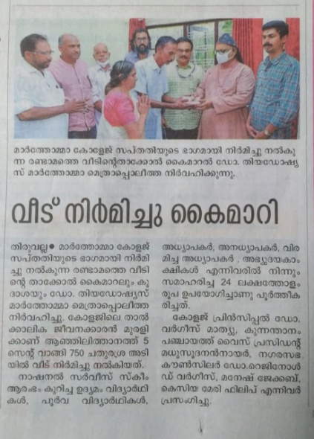

* **GREEN PROJECTS**
* **Energy Audit:** The Department of Physics conducted a study and published a survey report of energy audit on Energy Utilization and various energy conservation methods to the public.
* **Van Mahostava –Vidyavanam Project**: Department of Botany organised a Van Mahostava –Vidyavanam Project in association with Social Forestry Department. The project was inaugurated on 07-07-2021 by Sri. A K Saseendran, Hon. Minster of Forests.

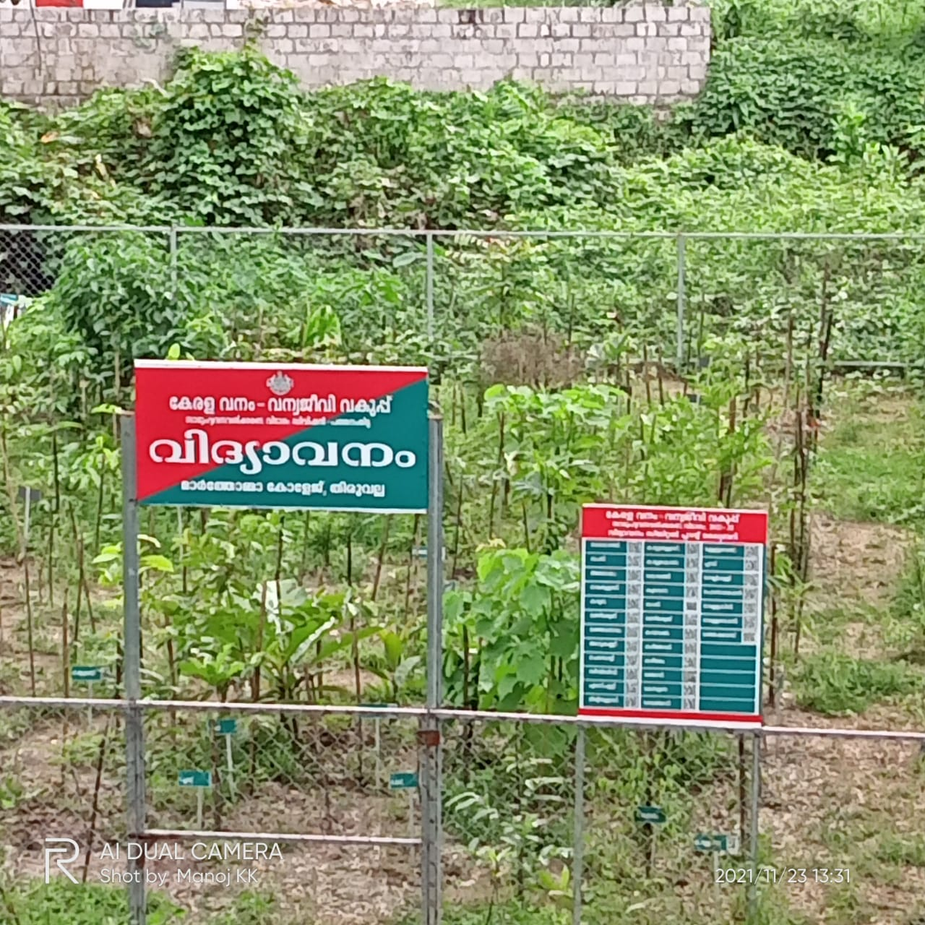

* **Miyawaki Forest:** The Miyawaki Forest is situated near the Women’s Hostel (Old**)** of Mar Thoma College, Tiruvalla in 5 cents of land. It consists of 420 plants( trees) spanning across 102 species. It is based on the methods of a Japanese forester and botanist named Akira Miyawaki, an expert in studying natural forests and restoring their native vegetation. It is an efficient technique for creating mini-forests quickly It works well because it follows the principles of natural forestry, which include employing local plants and imitating the processes of how forests regenerate naturally. Compared to more conventional methods of forest plantation, it has certain important advantages. It works very well in urban settings. In comparison to traditional forests, Miyawaki developed forest areas have been found to have more biodiversity and are proved to capture more carbon emissions. The goals of a Miyawaki technique include improving biodiversity, sequestering carbon, increasing green cover, lowering air pollution, and preserving the water table.

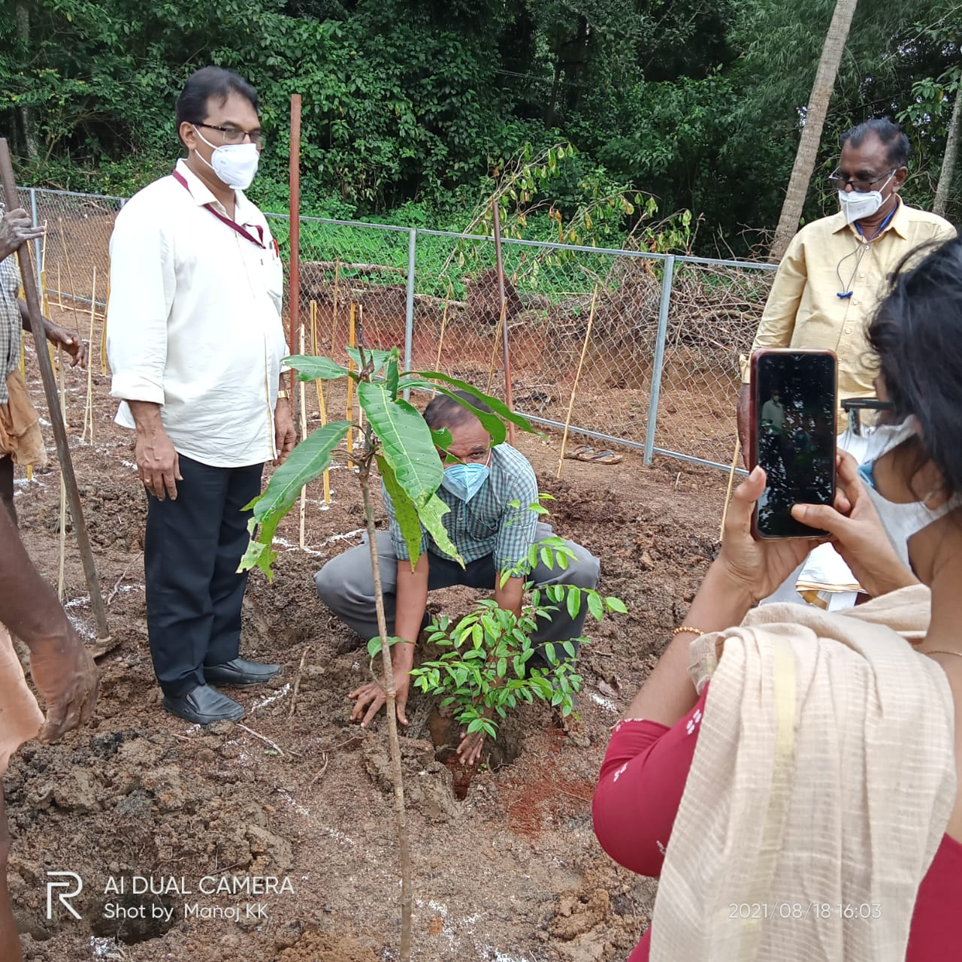

* **COVID CARE CENTRE**

The college participated in the Covid Care and Flood Relief measures with the help of the NSS and NCC units.

* NCC operated a COVID care help Centre in college especially for the Ward No08 of Mar Thoma College, Tiruvalla. Adv. Mathew T Thomas, MLA inaugurated the help desk on 12/05/2021.Cadets attended more than 150 calls and provided taxis, food, medicines etc.
* Members of the National Service Scheme delivered grocery items to the flood victims in the Peringara Panchayat in October 2021 and the Panchayat President and Ward Member received items and distributed to the flood victims.
* District administration hand overed the responsibility of Kuttor (District border of Pathanamthitta and Alappuzha, in MC Road) check post to NCC unit of MarThoma college Tiruvalla. 08 Cadets were deployed daily for checking the vehicle at Kuttor check post.2 PI staffs were also assigned for the safety of NCC Cadets.
* NCC unit of MarThoma College, Tiruvalla assisted the health department of Kerala in conducting and managing the examinations in college.NCC cadets helped in sanitizers distribution, temperature checking, traffic controlling, crowd management and organising awareness programmes





* **ANNADHANAM PROJECT** :

The NCC unit donated food to the poor patients in the Government hospital Tiruvalla. More than 100 patients in the Government hospital Tiruvalla were given food packets.

* **ACADEMIC EXTENSION – GRAMMAR SCHOOL**

The Department of English conducted Spoken English classes regularly for the High School, Chumathara. The students and teachers went as a team to conduct the classes in the school and held regular classes and activities for them.

